Parish Priest
Fr Jonathan Stewart
Priest in retirement
Fr John Watkins
PARISH OFFICE
The Presbytery,

Exeter EX1 2QJ
Telephone
01392 274724
Email exeter-heavitree
@prcdtr.org.uk
Parish Office hours
Tuesday, Wednesday and Thursday 10.00am–4.00pm
Parish Secretary
Lesley Hooper
Safeguarding Reps
Vince Clark &
Lesley Hooper
PARISH SCHOOL
St Nicholas Catholic
Primary School
Ringswell Avenue,
Exeter EX1 3EG
Telephone
01392 445403
Email admin@stncs.uk
www.st-nicholas-exeter.devon.sch.uk
Head Teacher
Angela Folland
CONVENT
Mount St Mary Convent, Wonford Road,
Exeter EX2 4PF
Telephone 01392 433301
Blessed Sacrament Parish is part of the Roman Catholic Diocese of Plymouth.
The Most Holy Body and Blood of Christ
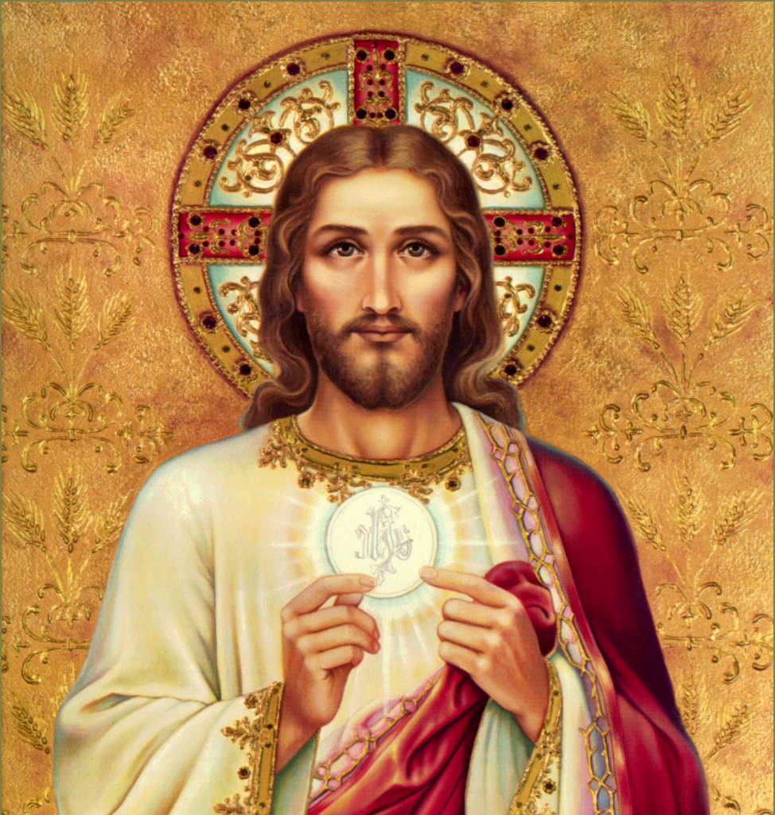

PENTECOST

Christ is our food and drink. Just as in human life we need food and drink so we need Christ to sustain us in our spiritual lives. He feeds us with himself just as God fed the Jews with manna in the wilderness. Our sharing of the one Body and Blood of Christ means that we share with each other Christ’s eternal life.
Welcome
We hope you have a happy and peaceful time with us here in Exeter. Please ask one of the Welcomers or contact the parish office if we can help in any way.
Liturgy of
the Word
for children
During the 10.30am Mass most Sundays.
Refreshments
Sunday after 10.30am Mass and Wednesday after 9.30am Mass.
Parents and
Toddlers
Monday mornings 9.30–11.30am in the St Richard Reynolds Centre. All welcome especially new faces.
Getting married?
Congratulations! Please give us six months’ notice if you are planning to marry in the Church.
Sick parishioners
Please inform one of the priests of the parish office if you know someone who is in need of a visit.
Newsletter
Deadline for newsletter items 4.00pm Wednesday. By phone or email.
Thank you
Sunday Collections
20 May £1,321.98
27 May £1,172.03
Calendar of Events
Sun 3 June Corpus Christi procession
Blessed Sacrament Church 3.00pm
Mon 4 June Adoremus Group Meeting
St Richard Reynolds Centre 7.00pm
Tues 5 June Pastoral Parish Council Meeting
St Richard Reynolds Centre 7.30pm
Wed 6 June EYCC Youth Group
St Richard Reynolds Centre 7.00pm
Thurs 7 June Cafod Group meeting
St Richard Reynolds Centre 7.00pm
Sat 8 June Livesimply meeting
St Richard Reynolds Centre 10.00am
Tues 12 June Parish Evangelising Team meeting
St Richard Reynolds Centre 7.30pm
Thurs 14 June Thursday Lunch Club
St Richard Reynolds Centre 12.30pm
Thurs 14 June Prayer Group
St Richard Reynolds Centre 7.00pm
Sun 17 June Mass in the Extraordinary Form
Blessed Sacrament Church 3.00pm
Mon 18 June Adoremus Group Meeting
St Richard Reynolds Centre 7.00pm
18–24 June Refugee Week. Please pray for all refugees
Wed 20 June EYCC Youth Group
St Richard Reynolds Centre 7.00pm
Fri 22 June St Nicholas School Summer Fayre
St Richard Reynolds Centre 7.00pm
Fri 22 June Run to the Sun
Buckfast Abbey until Sunday 24 June
Sat 23 June Server’s Rally and BBQ
Plymouth Cathedral 11.30am
Sat 23 June Diocesan Music and Liturgy Day
St Joseph’s Parish Hall Newton Abbot
Sun 24 June Annual Diocesan Youth Rally
St Rita’s Honiton 1.00–6.30pm
Tues 26 June Catholic Women’s League Meeting
St Mary’s Centre, Wonford Road 2.00pm
Thurs 28 June Prayer Group
St Richard Reynolds Centre 7.00pm
Fri 29 June Feast of St Peter and St Paul
Holyday of Obligation.
Masses 9.15am at St Nicholas School.
9.30am and 7.00pm in church.

Celebrating
Corpus Christi
Today we celebrate the patronal feast of our parish! The Blessed Sacrament is the Body and Blood of Jesus, Corpus Christi. How fortunate we are to have as our patron Jesus himself, given to us as food for our journey.
Today at 3.00pm we will expose the Blessed Sacrament in the church and then take the Lord in solemn procession around the grounds, ending with Benediction in the garden (weather permitting). During the procession we will stop at several ‘stations’ where we will listen to readings and prayers.
To spend time in adoration of Jesus in the Blessed Sacrament is one of the most wonderful privileges of our faith. We are being encouraged to take part as often as we can. The Eucharistic Congress being held in Liverpool later this year will focus our minds and hearts on the significance of the eucharist in our lives and encourage us to a deeper reverence and greater fondness for the Lord in holy communion.
What better way could there be to re-ignite our love for the Blessed Sacrament than to come along on Sunday and spend some time with Jesus, our Saviour and our friend. There will be tea!
Look forward to seeing you this afternoon.
We pray for…
…babies Niamh Goubran-Shuttlewood, Izamaria Biju, Aria Evans and Tomas Slipaitis who will be baptised next week and for their parents and Godparents. Becoming part of the Catholic community of the parish is an important moment in the life of any child and their family. We pray that they will all grow in knowledge and love of the Lord.
Adoremus 2018
Parish Groups on the Eucharist
In preparation for The Eucharistic Congress, in Liverpool in September, we will be running several parish groups.
The purpose of the groups will be: to help us grow in love and understanding of the Mass, our appreciation of the presence of Christ in the Eucharist, and foster our sense of mission which springs from the Eucharist. Everyone can participate and though most groups have already started you are still welcome to join one of them. There are also a series of podcasts that are available to help us understand further what, we as a church, are being invited to prepare for. Podcast 2: Journey like the magi: www.catholicnews.org.uk
/Home/Special-Events/Adoremus-National-Eucharistic-Pilgrimage/Let-Us-Adore-Him-Adoremus-Podcasts/Episode-2
Flores De Mayo
Luckily the rain held off for the procession of Our Lady in the grounds of the church last Saturday. The enthusiastic congregation enjoyed Mass with Fr Jimmy and the refreshments afterwards in the parish centre. Many thanks to all who came and supported this lovely May devotion. Our Lady, pray for us.
Secular Clergy Fund
Appeal 2018
Many thanks for your contribution last weekend which amounted to £454.09.
If you took a GiftAid envelope last weekend and are returning it today please put it in the collection basket.
Exeter’s Young Catholics
The next meeting of Exeter’s Young Catholic Community will be on Wednesday 6 June in the St Richard Reynolds Centre at 7.00pm. If you’re aged 16 to 21 you are most welcome to join us.
livesimply
Share the Journey in Exeter
Over the next few months, the livesimply action of our parish will focus on the global Share the Journey campaign that invites us to show solidarity with refugees and migrants www.cafod.org.uk/Campaign
/Share-the-Journey for more information. Later this summer, we will be organising a walk in Exeter as part of the campaign – more details to follow.’
Refugee Week 2018
During Refugee Week (18-24 June), there are a number of events being held in Exeter organised by local organisations. The programme is displayed in the church porch. Please take a look.
Sewing & Knitting Group
This newly formed livesimply group would love to welcome you to their meetings (dates to be posted soon) but in the meantime would be delighted to receive any donations of fabric, wool and haberdashery. These can be left in the porch clearly marked ‘Sewing Group’.
Exeter Foodbank
Sponsored Walk
You can support the work of the Foodbank by joining this sponsored walk on June 23. More information is available from walk@exeterfoodbank.org.uk or by phoning 07818226524
Exeter Foodbank Collection
There is a basket in church where you can leave your donations of non-perishable food. It will be collected every third Sunday in the month. Many thanks
The next livesimply meeting will take place on Saturday 9 June, 10.00am St Richard Reynolds Centre. All welcome!
Walsingham Pilgrimage
Marriage and family life pilgrimage 11–17 August at the Catholic National Shrine of Our Lady Walsingham. For more info visit www.walsingham.org.uk or email family@walssingham.org.uk or call 01328801007
1115 Youth Group
1115 Next Meeting AND Bowling Night
The next meeting will be on Friday June 8 at Exeter Tenpin Bowling. Preliminary costs are £11.20 per person plus any additional money for food, games, etc. Money will be collected at the bowling alley on the night so please ensure that your child has paid before dropping off. Any questions, please email Erik Renz at exter-youth-worker@prcdtr.org.
Attention parents: We would greatly appreciate anyone who is able to help chaperone the event. If you are able to volunteer (and if you’d like to bowl), please include this on your consent form. Thank you!
Run to the Son
Friday 22 to Sunday 24 June at Buckfast Abbey. A weekend of prayer and inspiration to help equip you for mission.
Tickets £50 inclusive of food and camping facilities (other accommodation available at additional cost). Booking forms online at www.buckfast.org.uk/run-to-the-son or contact St. Peter’s parish Plymouth on 01752 701660.
Music & Liturgy Day
With composer and liturgist Paul Inwood at St Joseph’s Parish Hall, Newton Abbot on 23 June. All are welcome including instruments. ‘Music for the Journey’ a day looking at a variety of music by different composers for times of sorrow and joy, and for moments when we are at changing points in our lives. Cost - £10 per person including tea/coffee.
Monsignor Harry
Doyle’s Golden Jubilee
Holy Cross in Topsham, Fr Harry’s current parish, is organising a collection in recognition of the work he has done for Plymouth diocese over the last 50 years including his work for Exeter Deanery. They will present him with a cheque and a small gift after the 11.00am Mass at Holy Cross on 10 June. If you would like to donate, please place your cash contribution in one of the envelopes in the porch and put it through the presbytery letterbox or hand in to the Parish office.
Celebration
of Priesthood
This annual Mass on thanksgiving will be celebrated at Plymouth Cathedral on Friday 8 June at 12.00pm. Bishop Mark will celebrate with the priests of the diocese, particularly those, like Fr Harry Doyle, who are celebrating silver and golden jubilees. You are most welcome to come and join in this wonderful celebration. Please continue to pray for the priests of our diocese and their ministry.
Mass Intentions
If you would like a Mass celebrated for a particular intention, for someone who is ill or a loved one who has died, in thanksgiving for an answer to prayer or perhaps something personal, please see Lesley in the parish office who will be able to help you find a date and time which suits you. It is traditional to make an offering at the same time. This is simply what you can afford and would like to give.
CAFOD pyramid boxes
£581.23. Many thanks for your generosity.
World Communications Day
£194.02. Many thanks for your generosity.
Adult server at Mass
So far we have had no response at all to our request for an adult to serve at the 10.30am Mass. Serving at Mass is a privilege and also a great joy. And it is not just for children! So please pray about it and if you feel called to this ministry please speak to Fr Jonathan.
Catholic Women’s League
The next monthly meeting will take place on Tuesday 26 June at Mount St Mary’s Centre, Wonford Road at 2.00pm.
World Meeting of
Families 2018
Pope Francis confirms he will travel to Ireland to take part in the ninth World Meeting of Families which takes place in Dublin 21–26 August. Visit website www.worldmeeting2018.ie/en/Tickets
for more information.
Altar Servers’ Rally,
Mass and BBQ
This annual Mass will be celebrated by Bishop Mark at Plymouth Cathedral at 11.30am on Saturday 23 June followed by a barbeque which should finish around 1.30–2.00pm. Bishop Mark would like as many altar servers as possible from the Diocese, and their families, to attend. Servers will need to take their albs or cassocks and cottas. A list will be placed in the sacristy for any of our servers who are going to add their name so that we can inform them how many to expect for catering purposes. Transport will not be provided but as families are invited we hope that you will all go along.
St Nick’s News
May Procession and Crowning
The whole school joined in the procession of the statue of Our Lady from the school field into the hall. The weather was glorious and parents and parishioners joined us for this lovely May celebration. The statue, with her crown of flowers took pride of place in the atrium afterwards, surrounded by the flowers which the children had brought to school for the occasion. Many thanks to all who came.
Half term
We have enjoyed our half-term break and are looking forward to returning to school for the last half term of the year. Please keep the school community in your prayers, especially those who are preparing to move to new schools in the autumn and those who will be joining the school and nursery.
New parishioners
Are you new to Blessed Sacrament parish? If so, you are most welcome and we hope you will be very happy here. If you haven’t already done so, please provide us with your contact details. Forms are available in the church porch and from the parish office (electronically) and should be returned to the office once completed. This also applies if you have been here for a while but not yet completed a form. It is good for us to know something about you and to be able to keep you updated with things happening in the parish. Thank you.
Youth Synod Gathering
2–5 July at Buckfast Abbey for 16–19 year olds. You are invited to respond to the call of Pope Francis to meet with other young people as part of the international preparations for the 2018 papal synod on Young People, Faith, and Vocational Discernment. Cost £50. Contact fiona.hutchings@prcdtr.org.uk for more information
St Mary’s Winslade School Reunion
Are you an ‘Old Boy’ of St Mary’s Winslade School? If so, you are invited to a reunion taking place on Saturday 16 June. Mass at 9.30am will be celebrated at Blessed Sacrament by Fr Jonathan, himself an ‘old boy’, followed by a get together at Cardinal Newman House from 11.00am till 6.00pm. Numbers attending are needed for catering so if you want to attend please contact the parish office for details on how to book or contact Pat Cauldwell at cauldwell@tinyworld.co.uk
Parish News now
every two weeks
We have decided to try publishing the parish newsletter every two weeks rather than every Sunday. We have included a Calendar of Events which is easy to refer to and will hopefully keep you in touch with what’s going on in and around the parish and diocese. Obviously this will mean that if you want an item to appear you will have to make sure it gets to the Parish Office in good time (by Wednesday afternoon). We also hope to have a notice board on the outside of the church doors so that even if the church is locked you will be able to find out the times of Masses etc.
Annual Youth Rally
St Rita’s Centre on Sunday June 24 1.00 till 6.30pm. Admission is £5.00. A bus will pick up at 12.15pm on the junction of Ringswell Avenue (St Nicholas School) and will return at 7.15pm. Further details can be obtained from Patrick on 01837 851438 or 07880 734088 pmorris@wjmorris.co.uk
More information and parental consent forms that must be completed for any youngster attending can be found in the church porch.
Community sponsorship of refugees
A free half day event for those interested in finding out more about the community sponsorship scheme, at The Old Deanery, Exeter on Wednesday 20 June from 10.00am till 12.00noon (registration from 9.30am). You can find out about the Government's new community sponsorship scheme for refugees. Go to: communitysponsorshipexeter.eventbrite.
co.uk to reserve a place and find more information at abide@otterystmary.org.uk
Catholic Summer Conferences
Would you like to know a little more about Catholic thinking, about how to grow in the spiritual life, how to begin to respond in love to those difficult questions about Catholic belief? The School of the Annunciation is offering four short conferences this summer in the beautiful surroundings of Buckfast Abbey - two in Spiritual Theology (12 to 15 June, and 30 July to 2 August), one in Philosophy (2 to 5 August), and one in Apologetics answering difficult questions of our time (9 to 12 August). Application forms can be downloaded from the School's website (https://www.schooloftheannunciation.com/site.php?menuaccess=57) or you can call the School direct - 01364 645660.
Natural Family Planning
Teacher Recruitment for Natural Family Planning (NFP) South West - helping to build a 'civilisation of love'
'...at the heart of civilisation is the family centred in marriage between a man and a woman that remains open to the gift of new life in children." (JP11 Letter to Families 1994) We are a volunteer organisation. We deliver the Billings Ovulation Method of NFP to engaged and married couples across the diocese and teach fertility awareness to teenagers. Applicants may be married/single but must be willing to chart their own fertility/use the method and be committed to the Church's teaching on Marriage and Family Life. To find out more, please ring or text Christine Hudson: 07742320717
Retreats
June 29 till July 1 weekend retreat at Southgate Retreat House. Booking forms available in the porch.
The Pope Tweets…
When the Holy Spirit is present, something always happens. Where blows the Spirit, things are never at a standstill
Thanks from SVP
The SVP would like to say a massive thank you to the many who supported our Summer Fayre on Saturday. We thank the Sisters, the CWL, the cake makers, those who gave us bric-a-brac, books and DVD’s and the small army of helpers who put it all together and manned the stalls. The funds raised will help us to continue our support for the Sisters’ Orphanage in the Philippines and the SVP baby feeding stations in Sudan. We also made a number of new friends so big thanks all round. If you would like to know more about what we do in the SVP you can contact Mike Eden on 07760 493940 or email mike.eden52@btinternet.com
Confirmation Photos
The photographs which were taken by Ola Godbeer at the recent Confirmations at Sacred Heart will be available on Saturday 9 June after the 5.30pm Mass and on Sunday 10 June after 10.30am Mass. Please come along and collect your photos on wither of those dates.
May she rest in peace
Please pray for the repose of the soul of
Jo Hobbs who died peacefully in hospital on Thursday last week. Details of her funeral will be published as soon as we have them.
Mass Times
Sunday 3 June
The Most Holy Body and Blood of Christ
9.00am Richard Ware RIP
10.30am People of the parish
3.00pm Corpus Christi Procession
6.00pm
Monday 4 June
8.00am Convent
Tuesday 5 June
St Boniface, patron of our diocese
7.00pm Church
Wednesday 6 June
9.30am Hilda and Edith Robinson
4.00pm RD&E Hospital
Thursday 7 June
No Mass
Friday 8 June
Sacred Heat of Jesus
No Convent Mass
9.30am Peggy RIP
Saturday 9 June
Immaculate Heart of Mary
9.30am Deceased members of Irvine & Charpenay families RIP
Sunday 10 June
Tenth Sunday in Ordinary Time
9.00am Brian Edworthy RIP
10.30am People of the Parish
6.00pm
Monday 11 June
No Convent Mass
Tuesday 12 June
7.00pm
Wednesday 13 June
St Anthony of Padua
9.30am
4.00pm RD&E Hospital
Thursday 14 June
9.30am
Friday 15 June
No Convent Mass
9.30am
Saturday 16 June
9.30am
10.00am Confessions
Sunday 17 June
Eleventh Sunday in Ordinary Time
9.00am People of the parish
10.30am
6.00pm
Confessions
Saturday 10.00am Church
Adoration
Mondays 9.30am Church
Tuesdays 8.00pm Convent

Please refer to the notice board on the church door for any alterations.

The Word
Sunday 3 June
First Reading
Exodus 24:3–8. This is the blood of the Covenant that the Lord has made with you.
Psalm Response
The cup of salvation
I will raise; I will call on
the Lord’s name.
Second Reading
Hebrews 9:11–15.
The blood of Christ can purify our inner self from dead actions.
Gospel
Mark 14:12–16. 22–26. This is my Body.
This is my Blood.
Sunday 10 June
First Reading
Genesis 3:9–15. I will make you enemies of each other: you and the woman.
Psalm Response
With the Lord there is mercy and fullness of redemption.
Second Reading
2 Corinthians 4:13–5:1.
We believe and therefore
we also speak.
Gospel
Mark 3:20–35.
It is the end of Satan.
Sunday 17 June
First Reading
Ezekiel 17:22–24.
I will make low trees grow.
Psalm Response
It is good to give you thanks O Lord.
Second Reading
2 Corinthians 5:6–10.
Whether we are living in
the body or exiled from it, we are intent on pleasing the Lord.
Gospel
Mark 4: 26–34. It is the smallest of the seeds; yet it grows into the biggest shrub of them all.

THIS is
my BODY
THIS is
my BLOOD

